TopoPerturb — A Beginner's Report
Oct 30, 2026 · @Tanisha

The question in one paragraph
Short answer: most "shape changes" we first saw after turning off genes were really the cell cloud getting bigger or stretched, not a new shape. One method, diffusion-distance persistent homology, ignores those simple changes and still finds real loops, and it flags the strongest knockdowns in both cell lines.
Scientists can switch off one gene at a time in many cells and then measure which genes are active in each cell. Each cell becomes a point in a high-dimensional space. Normal cells form a cloud of points. When a gene is switched off, the cloud moves or changes. We asked a simple question: does the cloud only move, grow or stretch, or does its shape really change, for example by forming a ring or splitting into groups? A tool from mathematics called persistent homology is meant to detect shape. We tested whether it really detects shape, or whether it is fooled by simple size and stretch changes.

Key ideas, explained simply
You need only seven ideas to follow this report. A picture of the main one, geometry versus shape, is in the next section.
- A cell is a point. We measure about 600 genes in each cell. The list of 600 numbers places the cell as one point in a 600-dimensional space. Cells that behave alike sit close together.
- A knockdown. CRISPR is used to switch off ("knock down") one chosen gene in a group of cells. We compare these cells with control cells, where no gene was switched off.
- PCA (principal component analysis). 600 dimensions is too many to work with. PCA squeezes the data into the 30 directions that carry the most variation. We call them PC1, PC2 and so on.
- Geometry versus shape (topology). A cloud of cells can change in simple ways: it can move (translation), grow (scaling) or stretch in some directions (anisotropy). None of these changes its shape. A true shape change is something like a hole (a ring of cells) or a split into two groups.
- Persistent homology (PH). Imagine putting a small ball around every point and slowly growing the balls. As they grow, they touch and join. PH records when separate groups merge (called H0) and when rings appear and later fill in (called H1). A ring that lasts a long time is a real loop. A ring that disappears quickly is noise. The result is drawn as a persistence diagram.
- Comparing two diagrams. The Wasserstein distance measures how different two persistence diagrams are. A larger number means the shapes look more different.
- Is the difference real? (p-values). We shuffle the labels "control" and "knockdown" many times and recompute the distance. If the real distance is bigger than almost all the shuffled ones, the difference is unlikely to be chance. The p-value is the fraction of shuffles that beat the real one. We call p < 0.05 a detection. When we test many genes at once, we use a correction (Benjamini–Hochberg) and report a q-value.

Data we used
We used two public CRISPR knockdown datasets from the CausalBench benchmark. Both come from the large Perturb-seq study of Replogle et al. (2022).
Dataset | Cell type | Cells | Genes measured | Genes knocked down | Link
K562 | Leukemia cell line | 162,751 | 622 | 622 | Hugging Face: causalbench-k562
RPE1 | Retinal epithelial cell line | 162,733 | 383 | 383 | Hugging Face: causalbench-rpe1
- Each cell has a label: the gene that was knocked down, non-targeting (a control cell) or excluded (not used).
- The values are already normalized and log-transformed, so we did not re-process them.
- 118 knocked-down genes appear in both cell lines.
- The files have no guide or batch information. This limits what we can say (see Limitations).
Background papers: CausalBench (Chevalley et al.) · Replogle et al., Cell 2022 · Spectral distances for PH (Damrich, Berens & Kobak, NeurIPS 2024).

What we did, step by step
The work went through five steps. Each step tested whether the previous result could be trusted.
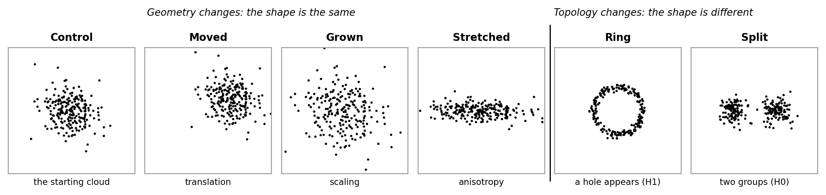
Figure 1. The difference we care about. The first four clouds have the same shape: they are only moved, grown or stretched. The last two really change shape: a ring has a hole, and a split makes two groups.

Step 1 — Check the data
We counted cells, genes and labels in both datasets. Most knocked-down genes have a few hundred cells, which is enough for our tests. We kept only the control cells and the knockdown cells, and dropped the "excluded" cells.

Step 2 — Pick a small set of genes and look at them
We chose 8 K562 genes: POLRMT, GFM1, ZMAT2, CPSF3, RPL21, POLR2B, DLD and NCBP2. Some were chosen as pairs with a similar job in the cell (for example GFM1 and POLRMT, both in mitochondria) so we could compare them. We reduced the data to 30 PCA directions and drew simple maps (PCA plots and Mapper graphs). The knockdown cells were shifted away from control cells, but no clear ring or split was visible by eye.

Step 3 — First persistent homology test
For each gene we took 150 control cells and 150 knockdown cells, computed their persistence diagrams, and measured the Wasserstein distance between them. To know what "normal" variation looks like, we also compared 150 control cells with another 150 control cells. Several genes, especially NCBP2 and POLR2B, gave much bigger H1 differences than control-versus-control.

Step 4 — Make it more careful (Phase 1)
We repeated the test with 2,000 label shuffles. We also changed the settings: 10, 20, 30 or 50 PCA directions, and 100, 150 or 200 cells. NCBP2 and POLR2B stayed significant in all 12 settings. But when we looked at the diagrams (Figure 2), the knockdown points sat further to the right. This means the rings appear later because the whole cloud is bigger (23% bigger for NCBP2, 36% for POLR2B), not because there is a new ring.
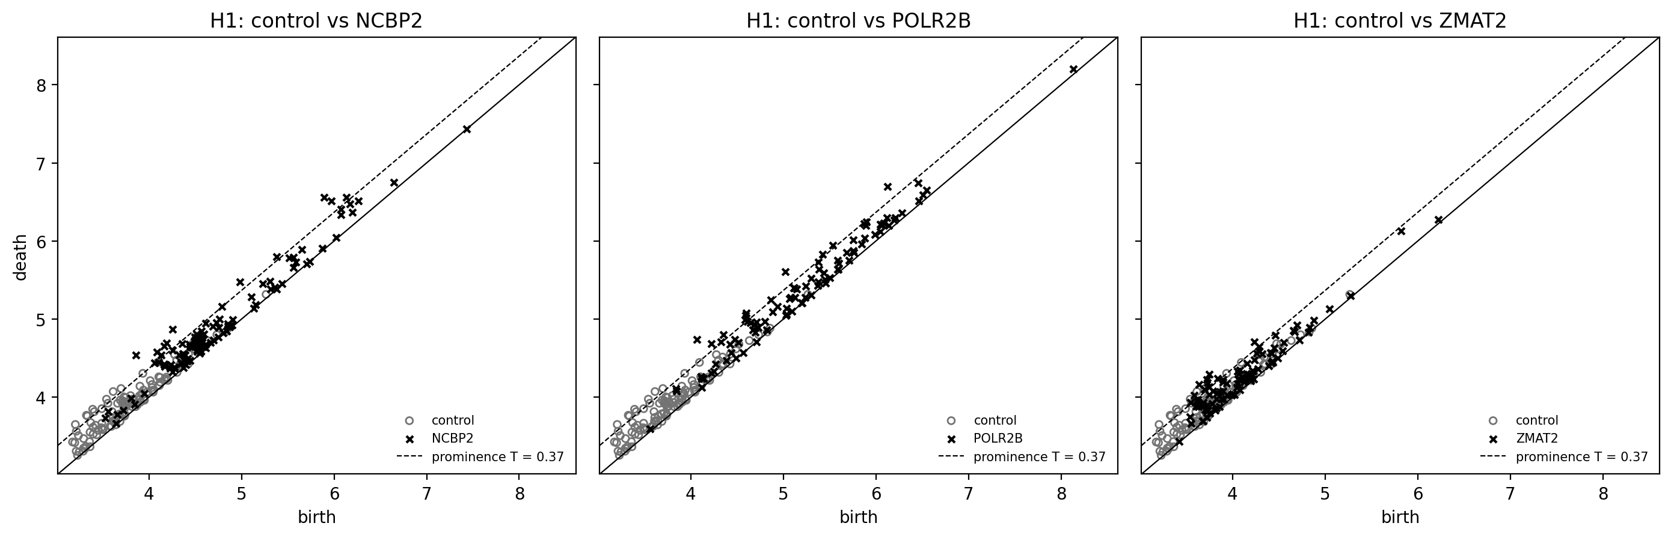
Figure 2. H1 persistence diagrams. Circles are control cells, crosses are knockdown cells. Each mark is a small ring: "birth" is when it appears and "death" is when it fills in. For NCBP2 and POLR2B the crosses are shifted up and to the right, which is what a larger cloud does. No cross sits far above the diagonal, so there is no long-lasting loop.

Step 5 — Remove the size effect and compare with other methods (Phase 2)
- Scale normalization. We divided each cloud by its own average distance between cells, so that size no longer matters. After this, no gene was significant with Euclidean PH.
- Ordinary statistics. Simple tests such as the average shift (centroid), energy distance and spread found all 8 knockdowns. So these knockdowns clearly change the cells; the question is only whether the shape changes.
- Stretch. A measure of stretch (the participation ratio) showed that POLR2B and RPL21 squeeze the cloud into fewer directions. This explained the small PH signals that were left for those two genes.
- Other distances. We also tried two "spectral" distances that follow the cells along a neighbor graph: effective resistance and diffusion distance. Diffusion distance flagged RPL21 (q = 0.032).
- RPE1. In the second cell line, PH found nothing for ZMAT2, CPSF3, POLRMT or GFM1.
- Gaussian copies. We made fake clouds with the same average and the same spread as the real ones but no special shape. These copies gave about the same PH differences as the real cells.
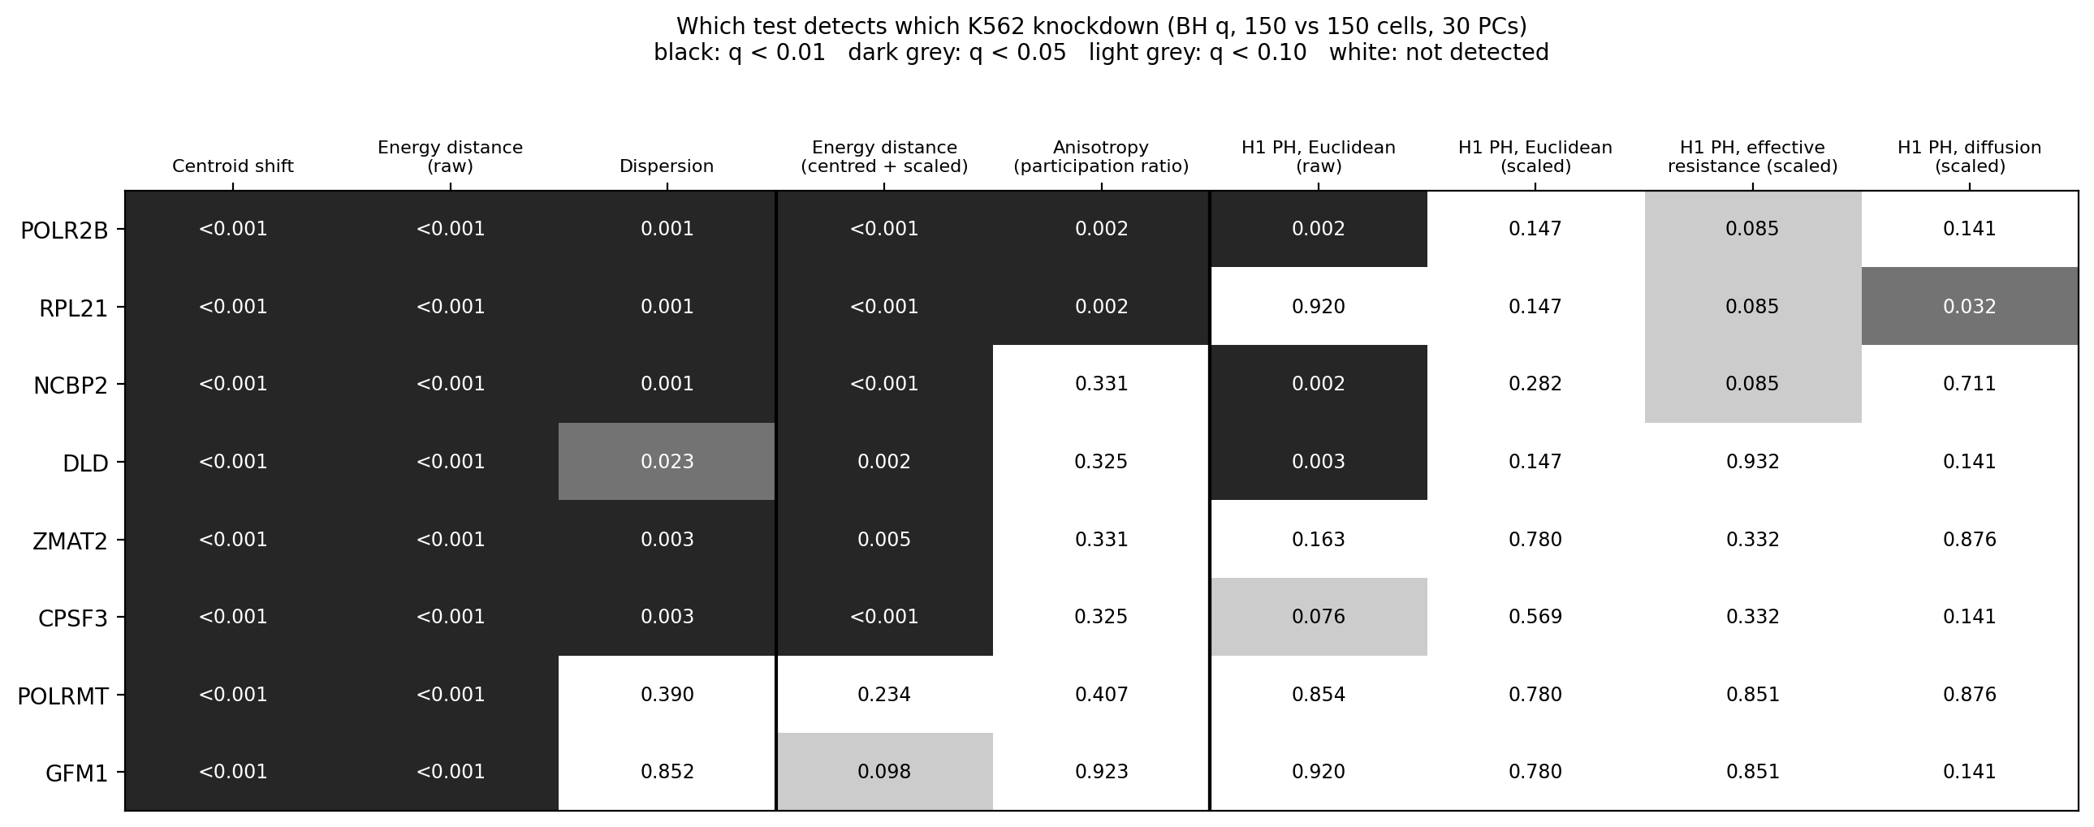
Figure 3. K562 results before the benchmark. Each cell shows a q-value; darker means a stronger detection. Ordinary tests (left) detect every knockdown. Raw PH detects only the genes whose cloud grew. After scaling, Euclidean PH detects nothing.
At this point the story was "PH only sees size and stretch". But one question was open: is PH able to see a real ring in data like ours at all? If not, finding nothing proves nothing. Step 6 answers this.

Step 6 — The synthetic benchmark (a test where we know the answer)
Result: ordinary Euclidean PH cannot see a ring at K562 noise levels, but diffusion-distance PH can, and it is not fooled by size or stretch.

What we did
We built fake cell clouds on the computer, so we knew the right answer in advance. Each fake cloud had 150 cells in 30 dimensions, with the same spread of variation as real K562 control cells. We then compared a control cloud with a changed cloud, 40 times for each change:
- Geometry only (the answer is "no shape change"): same cloud, moved, grown 1.3×, stretched, and heavy-tailed (a few extreme cells).
- Mixture: a partial knockdown, where 70% of cells moved and 30% stayed normal, like real "escaper" cells.
- Real shape change (the answer is "yes"): a ring hidden in PC1–PC2 with K562-like noise, two clusters, and a ring with four noise levels. In these clouds the average and spread were made exactly the same as the control, so only the shape differs.
Every comparison went through the same 10 tests: 2 ordinary tests, 5 PH tests and 3 "Gaussian copy" tests (Step 5). We counted how often each test said "different" (p < 0.05). A good shape test should say "different" about 5% of the time on geometry rows (that is chance) and often on shape rows.
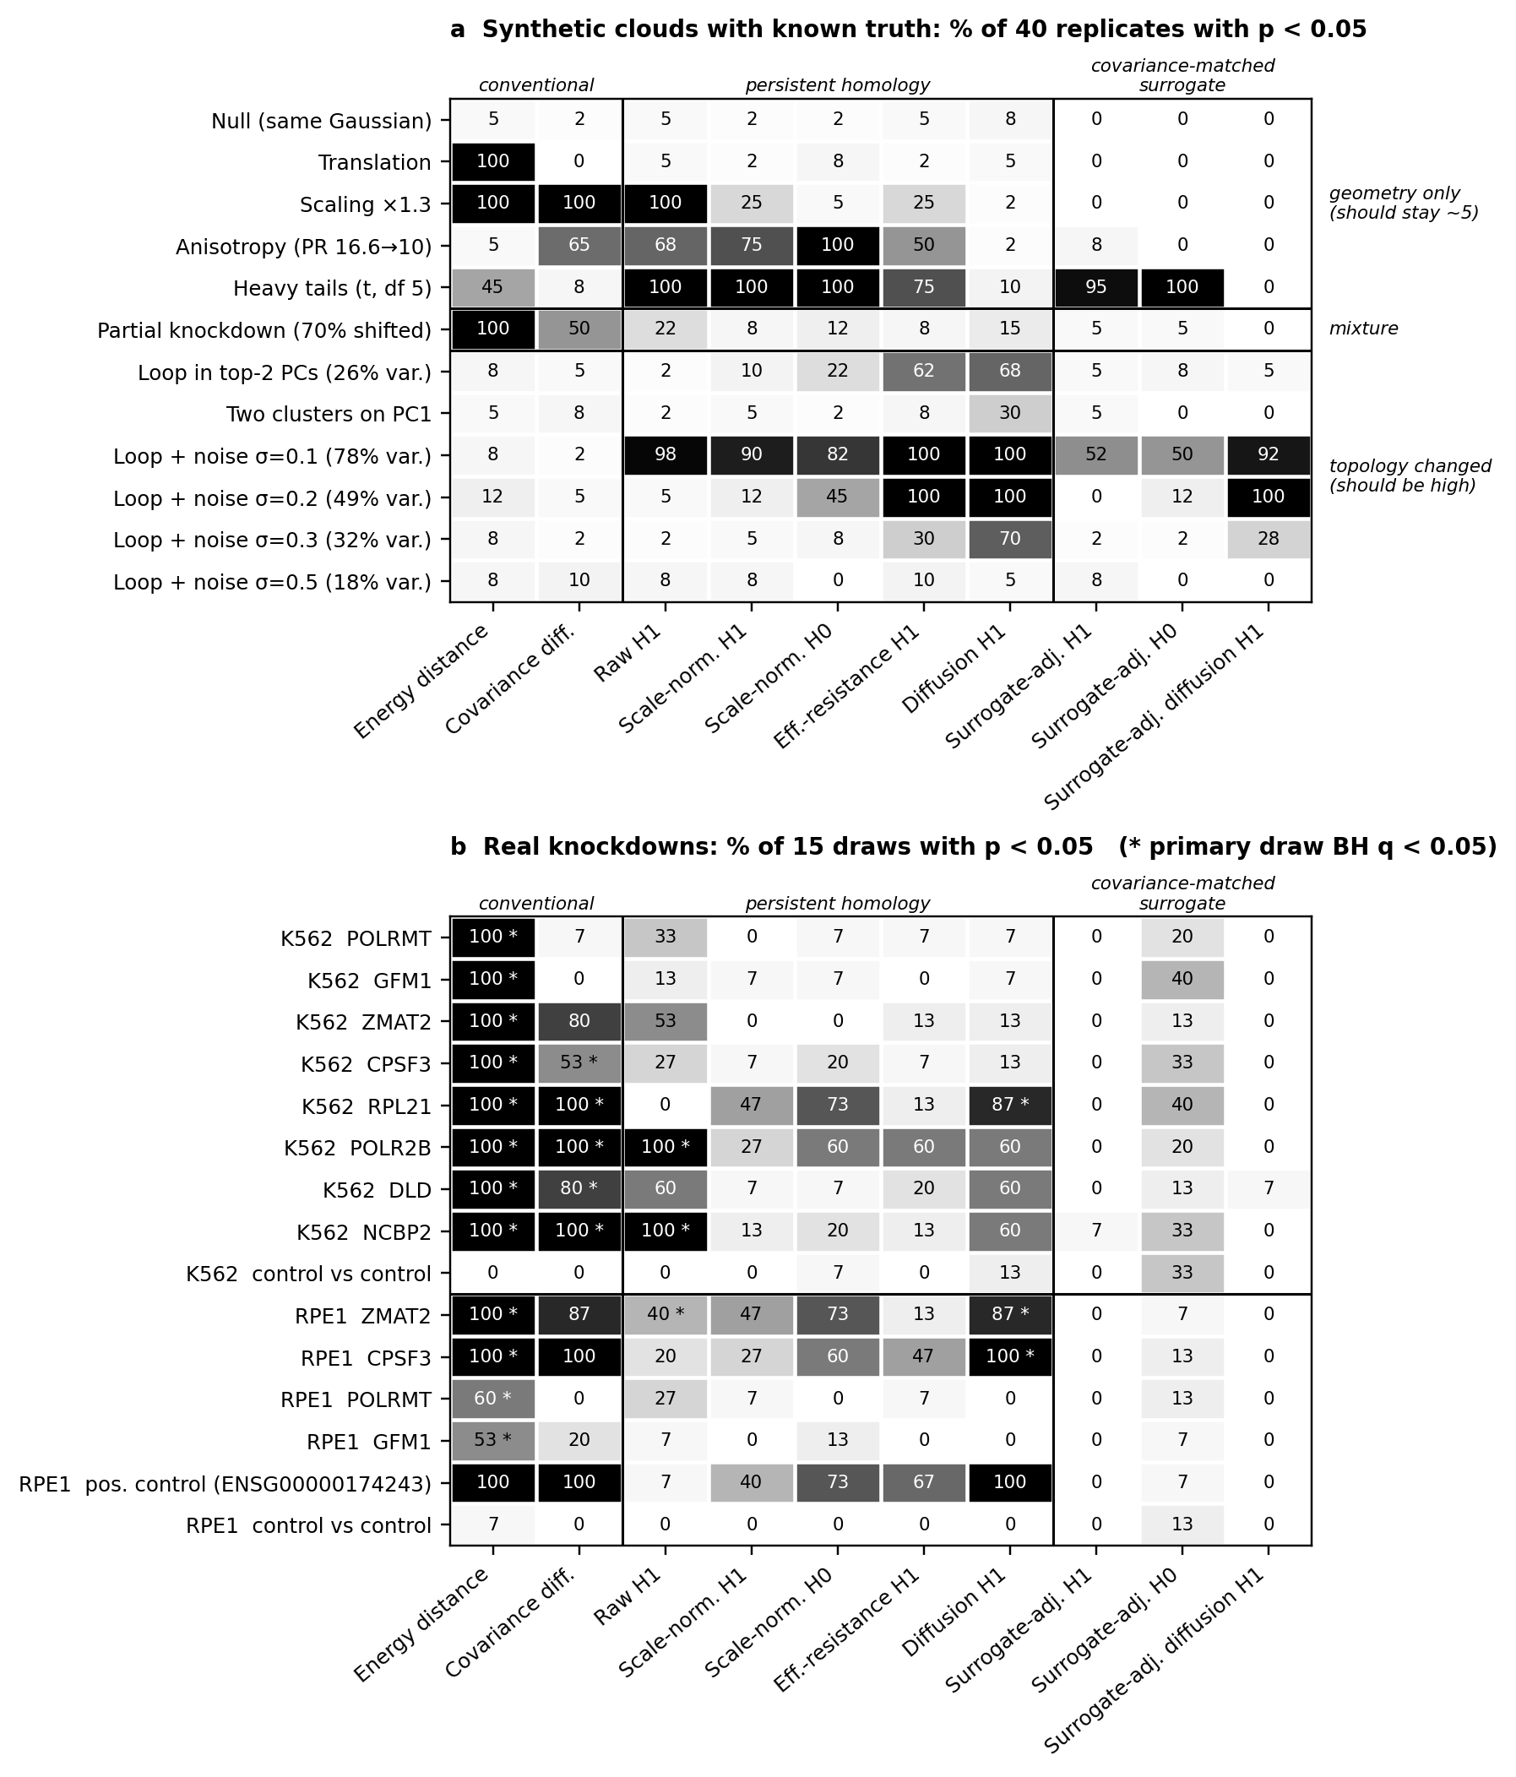
Figure 4. Panel a: fake clouds with a known answer. Panel b: real knockdowns (next section). Each number is the percent of tries where the test said "different". Black = always, white = never. The first five rows of panel a (geometry only) should stay near 5 for a shape test; the bottom rows should be high.

What it shows
What changed | Raw H1 | Scaled H1 | Diffusion H1 | Gaussian-copy H1
Nothing (same cloud) | 5% | 2% | 8% | 0%
Grown 1.3× | 100% | 25% | 2% | 0%
Stretched | 68% | 75% | 2% | 8%
Heavy tails | 100% | 100% | 10% | 95%
Partial knockdown | 22% | 8% | 15% | 5%
Ring in PC1–PC2, K562 noise | 2% | 10% | 68% | 5%
Ring, medium noise | 2% | 5% | 70% | 2%
Ring, very high noise | 8% | 8% | 5% | 8%
- Raw PH is fooled by size. It said "different" in all 40 tries when the cloud only grew.
- Scaling fixes size but not stretch. Scaled PH still said "different" 75% of the time for a stretched cloud. This explains the POLR2B and RPL21 signals in Step 5.
- Euclidean PH is blind to a ring at K562 noise. It found the hidden ring only 2–10% of the time. So the "nothing found" in Step 5 does not prove there is no ring.
- Diffusion PH is the best shape test. It ignored moving, growing and stretching (2–10%, close to chance), and found the ring 68–100% of the time until the noise became very high.
- The Gaussian-copy tests are not a good fix. They rarely found the ring, and they reacted strongly to heavy tails, which are not a shape change.

Step 7 — The same tests on the real knockdowns
Result: diffusion PH flags the strongest knockdowns in both cell lines, and stays quiet when we compare control cells with control cells.
We ran the same 10 tests on real cells: the 8 K562 genes, the 4 RPE1 genes, one strong RPE1 knockdown as a positive control, and control-versus-control in each cell line as a check for false alarms. Each comparison was repeated on 15 different random draws of 150 + 150 cells (Figure 4, panel b).
Cell line | Group | Diffusion H1 (% of draws) | Significant after correction?
K562 | RPL21 | 87% | Yes (q < 0.05)
K562 | POLR2B, DLD, NCBP2 | 60% each | No
K562 | ZMAT2, CPSF3, POLRMT, GFM1 | 7–13% | No
K562 | Control vs control | 13% | — (false-alarm check)
RPE1 | CPSF3 | 100% | Yes (q < 0.05)
RPE1 | ZMAT2 | 87% | Yes (q < 0.05)
RPE1 | POLRMT, GFM1 | 0% | No
RPE1 | Positive control | 100% | —
RPE1 | Control vs control | 0% | — (false-alarm check)
- Ordinary tests (energy distance) detected every K562 knockdown in all draws, as before.
- Raw Euclidean PH again followed cloud size: it was strongest for POLR2B and NCBP2, the two genes whose clouds grew most.
- The Gaussian-copy H0 test said "different" in 33% of K562 control-versus-control draws. Real cells are not perfectly Gaussian, so this test gives false alarms on real data.

What we infer
Main conclusion: before calling a PH change "new shape", you must rule out size and stretch, and you must check that your method can see a real ring at your noise level.
- Most early PH signals were geometry. The big H1 differences for NCBP2 and POLR2B came from larger clouds. The leftover signals for POLR2B and RPL21 came from stretched clouds.
- "No shape found" was not the same as "no shape". Euclidean PH could not find a ring hidden in K562-like data, so our earlier negative result was not strong evidence.
- Diffusion-distance PH is the right tool for this data. In the benchmark it was the only PH test that ignored size and stretch and still found rings. This agrees with the NeurIPS 2024 paper by Damrich, Berens & Kobak, now shown on gene-knockdown data.
- Some real knockdowns change the cell cloud beyond moving, growing or stretching. Diffusion PH flagged RPL21 in K562 and CPSF3 and ZMAT2 in RPE1, while control-versus-control stayed near chance.
- We cannot yet say it is a ring. Diffusion PH also reacts somewhat to clusters (30% in the benchmark) and partial knockdowns (15%). The signal could be a loop or a subgroup of cells, such as cells where the knockdown did not work. The honest wording is "structure beyond simple geometry".
- Ordinary statistics are still the best way to ask "did anything change?" They detect every knockdown. PH is useful for a different question: "did the shape change?"

Where our novelty is
Our new contribution is a tested recipe for telling geometry from shape in gene-knockdown data, with a benchmark that shows which PH method passes and which fails. We did not invent persistent homology or spectral distances. What is new is putting them on trial, with known answers, in the exact setting of CRISPR knockdown data.
Already known (other people's work) | What we add
PH can react to geometry, not only to shape (Turkeš et al., NeurIPS 2022) | We measure how much, in real knockdown data: size explains the raw signals, stretch explains the scaled ones
Spectral distances help PH in noisy, high-dimensional data (Damrich et al., NeurIPS 2024) | We show diffusion PH is the only tested PH method that passes our geometry checks and still finds rings at K562-like noise and 150 cells
CausalBench is used to benchmark gene-network methods (Chevalley et al.) | We use it to benchmark shape claims about knockdowns, in two cell lines
Gaussian copies are a common "null model" | We show they have little power here and give false alarms on real cells, so they should not be the main check
In one sentence for the poster: apparent shape changes after gene knockdowns are mostly size and stretch; a simple benchmark with known answers shows which PH method can be trusted, and that method still finds structure beyond geometry in the strongest knockdowns.
We should not claim to be "the first". A short literature search is still needed before submission.

Limitations and next steps
Limitations
- Draws are not true replicates. The 15 real draws reuse many of the same cells, so the percentages show stability, not independent proof.
- No guide or batch information. The dataset copies do not say which CRISPR guide or experiment batch each cell came from. We cannot rule out batch effects.
- Small numbers. We tested 8 K562 genes and 4 RPE1 genes, with 40 fake tries per condition. A rate near 50% has an uncertainty of about ±15 percentage points.
- One setting for diffusion. We used 15 neighbors and diffusion time 8. Other settings may change the results.

Glossary
Word | Simple meaning
Knockdown | Switching off one gene in a group of cells using CRISPR
Control cells | Cells where no gene was switched off (non-targeting)
PCA / PC | A way to squeeze many genes into a few main directions of variation
Geometry | Where the cloud is, how big it is and how stretched it is
Topology / shape | Holes and separate pieces; things that stay the same when you move, grow or stretch
Persistent homology (PH) | A method that grows balls around points and records when pieces join (H0) and when rings form and fill (H1)
Persistence diagram | A plot of when each piece or ring appears (birth) and disappears (death)
Wasserstein distance | A number saying how different two persistence diagrams are
Euclidean distance | Straight-line distance between two cells
Diffusion distance | Distance measured by walking between neighboring cells, so noise matters less
Effective resistance | Another neighbor-graph distance, like electrical resistance in a network
Scale normalization | Dividing a cloud by its average distance between cells so size no longer matters
Participation ratio | How many directions a cloud really spreads in; a lower value means more stretched
Gaussian copy (surrogate) | A fake cloud with the same average and spread as the real one, but no special shape
Permutation test | Shuffling labels many times to see if a difference could be chance
p-value / q-value | Chance of a difference this big by luck; q is corrected for testing many genes
Energy distance | A standard test for whether two groups of points come from different distributions
Benchmark | A test set where the right answers are known in advance

